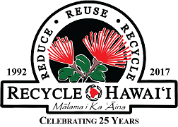
Recycle Hawai‘i
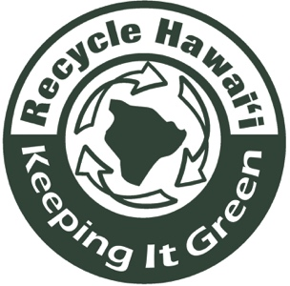
PO Box 4847 • Hilo, HI • 96720
Phone: 808.969.2012
info@recyclehawaii.org
www.recyclehawaii.org

Keeping It Green Hawai‘i Award
Nomination Application

Your Name: Date:
Phone: E-Mail:

I nominate the following organization for a Keeping It Green Hawaii Award.

Name of Organization:

Address:

Phone: Email:

Fax: Website:

Nominee Contact:
Phone: Email:

Qualifying nominees demonstrate ongoing green practices, projects and services in at least three of the following areas:

• 3 R’s: reduce, reuse, recycle
• Zero waste systems or ZW events
• Gardening, composting, green/bio-waste, agriculture, forestry
• Ocean, water conservation
• Youth or community service, educational projects
• Native species, native habitat
• Sustainable industry; green building
• Energy, fuel and resource conservation or alternatives
• Open space “greenways”, beautification
• Climate change
• Indigenous gathering rights and cultural practices

For each area sited:
- Describe the community need and what impact the organization’s activities, programming and services have had to address the identified need. (up to 2 pages)
- Include (2) supportive documents e.g. letter of support, article, press release, etc.
- Include (2-3) photos with captions and photo credit.
- Submit application form, narrative, supportive documents and photos by Nov 15 of the nomination year to:
info@recyclehawaii.org
or
Recycle Hawai‘i, PO Box 4847, Hilo, HI 96720

